Predicting Formula 1 Race Outcomes: Evaluating the Roles of Drivers and Constructors Over Time
Saurabh Rane (rane.saurabh7@gmail.com, saurabhr.com)
July 17th 2024
Predicting Formula 1 Race Outcomes: Evaluating the Roles of Drivers and Constructors Over Time 1
Abstract 2
1. Introduction 2
2. Data Processing 3
3. Methods 4
3.1. Linear Model With Ridge Regression 4
3.2. Features 5
3.3. Coefficient Smoothing 5
3.4. Testing 6
3.5. Additional Models 7
4. Results 8
4.1. Linear Model Results 8
4.2. Logistic Model Results 9
4.3. Driver and Constructor Coefficients 10
5. Discussion 11
5.1. Model Discussion 11
5.2. Model Extensibility 11
5.3. Applications & Conclusions 12
References 13
Appendix 13
A1. Metrics by Driver-Season Type 14
A2. Parent Constructor Mapping 15
A3. Driver/Constructor Ratings as of 2024 British GP 15
A4. Driver/Constructor Coefficient/Ratings Trends 2014 - 2024 British GP 17

Abstract
Formula 1 performance is a mixture of the car’s ability and the driver’s ability. While a given race or season can tell you how well a car and driver performed jointly, discerning the individual impact of the driver and constructor remains challenging.
This paper extends the Regularized Adjusted Plus Minus (RAPM) methodology, commonly used in basketball and hockey, to identify individual driver and constructor impact. It employs a time-decayed ridge regression with LOESS smoothing to predict race results for the “Hybrid Engine Era” (2014 – Present). By mapping the constructor and driver coefficients over time, we measure the relative impact of these individuals throughout the period.
Results show that constructors explain 67.1% of the variance in race outcomes, compared to ~88% in previous studies. Additionally, constructors have increased importance in benchmarked rank-agnostic cohorts (e.g., Top 10 points finishers) and decreased importance in qualifying.
This approach offers a robust framework for inter-constructor driver comparisons and provides a basis for extending the model to previous F1 seasons and other racing-based sports. Our work enhances the understanding of driver and constructor contributions to race success, offering valuable insights for strategic decision-making in Formula 1.

Introduction
The realm of sports often celebrates the exceptional athletic prowess of individuals or teams, and Formula 1 is no exception. Victorious drivers are traditionally lauded with champagne showers and podium ceremonies. However, the success of a driver is not solely attributable to their skills. As 2016 World Drivers’ Champion Nico Rosberg remarked, success in Formula 1 is “20 percent driver and 80 percent car” (Spurgeon, 2009).
The significance of the car's role is evident in the historical data. Since 2000, the World Constructors’ Champion has only twice differed from the team of the World Drivers’ Champion (Formula 1). Moreover, in the ten completed seasons of the Hybrid era, the World Drivers’ Champion and runner-up have hailed from the same team on six occasions.
While it is well-acknowledged that constructors play a pivotal role in Formula 1 success, there is a need to delve deeper into the individual variances attributable to constructors and drivers. Prior analyses (Keresten, 2023; Rockerbie, 2021; Bell, 2016) have explored the overall variance explained by constructors versus drivers, often assigning “skill” values to each.
Our objective is to develop a predictive model robust enough to forecast future races accurately. Using this model, we aim to quantify the individual impacts of constructors and drivers. Current comparisons of teams (inter-constructor) and drivers within the same team (intra-constructor) are straightforward through Formula 1’s point system. However, comparing drivers across different teams (inter-constructors) remains challenging due to the dominant influence of the constructor.
Moreover, our approach differs from the existing literature. Bell (2016) and Keresten (2023) have produced the most prominent and similar work in the field. Bell's methodology treats a driver's entire career as a single entity, while Keresten's analysis is conducted at the season level. In contrast, our model evaluates driver and constructor ratings at a race-level granularity. This finer level of detail allows for a more responsive assessment of driver and constructor performance.
Finally, we seek to enhance our understanding of the relative contributions of constructors and drivers in determining race outcomes over time, providing a more nuanced analysis of their impacts on race rankings.

Data Processing
We collect data from all Formula 1 races through the Ergast API via the f1dataR R package (Ergast, f1dataR). Our analysis primarily focuses on the hybrid engine era (2014 to present), utilizing race results from 2012 onwards to provide a warm start.
For our primary model, we exclude non-finishers (DNF) to avoid the additional noise and complexity they introduce to the outcome of interest, as similarly noted by Keresten (2023). Assigning the root cause of certain DNFs, particularly driver-driver collisions, can be challenging. Given the time-decay and point-in-time nature of our study, indexing on DNFs may disproportionately add negative noise to a driver or constructor coefficient. However, we also test model variants that include DNFs wholly and another that partially assigns DNF cause to either driver or constructor based on the type of DNF. DNFs categorized as Collision, Accident, or Spun-Off are attributed to driver fault, while other causes are attributed to constructor fault.
The features used in the model are binary indicators for the parent constructor and driver at the race level. The term "parent constructor" refers to constructors that have undergone name changes but remain the same underlying entity. For example, Toro Rosso, Alpha Tauri, and RB are considered the same constructor in this analysis.
The response variable is the rank finish of the driver-constructor pair in a given race. Points-scoring positions (ranks 1 to 10) are weighted equally, as drivers are expected to compete equally for these positions. Positions beyond 10 are weighted on a linear decay until the last position, reflecting the expectation that the effort expended for lower places is probably less than that for the top places (Henderson, 2021). The calculation of rank finishing weights is seen below in (1).

$${weight}_{Rank Finish} = \left\{\begin{aligned}1, &Position≤10 \\ \frac{{Cars}_{Outside Points} - \left(Position - 9\right)}{{Cars}_{Outside Points} + 1}, &Position>10\end{aligned}\right.$$
$${Cars}_{Outside Points}={Cars}_{Total}-10$$
(1)

Methods

Linear Model With Ridge Regression
We employ a linear model with ridge (L2) regression. The input data comprises a sparse matrix of parent constructors and drivers. Ridge regression is chosen because it includes drivers with limited data by shrinking their coefficients, unlike L1 regularization which would remove them entirely. This allows us to maintain unique coefficients for each driver and constructor. This approach allows for unique coefficients representing each driver and constructor. The matrix equation for the ridge regression model is seen below in (2).

$$Xβ=Y$$
$$\left(\begin{matrix} & red_bull & ferrari & mclaren & … & hamilton \\ R_{2012, Austraila} & 1 & 0 & 0 & … & 0 \\ R_{2012, Austraila} & 0 & 1 & 0 & … & 0 \\ R_{2012, Austraila} & 0 & 0 & 1 & … & 1 \\ ⋮ & ⋮ & ⋮ & ⋮ & ⋱ & … \\ R_{2023, Abu Dhabu} & 1 & 0 & 0 & … & 0\end{matrix}\right)\left(\begin{matrix}β_{red_bull} \\ β_{ferrari} \\ β_{mclaren} \\ ⋮ \\ β_{hamilton}\end{matrix}\right) = \left(\begin{matrix}Y_{red_bull|driver} \\ Y_{ferrari|driver} \\ Y_{mclaren|hamilton} \\ ⋮ \\ Y_{red_bull|driver}\end{matrix}\right)$$
(2)
We iteratively run the regression for each race from 2012 to the present. For example, to predict the 2016 Monaco Grand Prix (2016 season, round 6), training data from all races from 2012 up to the 2016 Spanish Grand Prix (2016 season, round 5) are used. More recent results are weighted higher than older ones, as defined by the equations highlighted in (3), where constants are optimized against mean absolute error (MAE). This exponential decay approach is borrowed from similar NBA player impact ratings which utilize ridge regression (Mevedovsky).

$${weight}_{season} = e^{0.75 * (Current Season - Race Season)}$$
$${weight}_{round} = e^{0.075 * (Current Round - Race Round)}$$
$${weight}_{time decay} = {{weight}_{season} * weight}_{round}$$
(3)
We combine the time-decay weights with the rank position weights described in section 2 as shown in (4).
$${weight}_{overall} ={{weight}_{Rank Finish}* weight}_{time decay}$$
(4)
The use of a time-decayed ridge regression lets us gain some of the benefits of a random effect model (Bell 2016), namely the shrinking of large low sample residuals and capturing point-in-time performance

Features
As discussed in the Introduction, the features used are a sparse matrix of parent constructors and drivers. Unlike Keresten and Bell’s work, which included weather conditions, we exclude weather due to its unpredictability before a race weekend. Circuit type (street vs permanent circuit) was considered but ultimately excluded for simplicity.

Coefficient Smoothing
As mentioned in section 3.1, we use the coefficients for a given constructor and driver as a measure of their impact over time. However, due to the nature of our time-decay weighting, the time-series view can be noisy as seen in the figure below
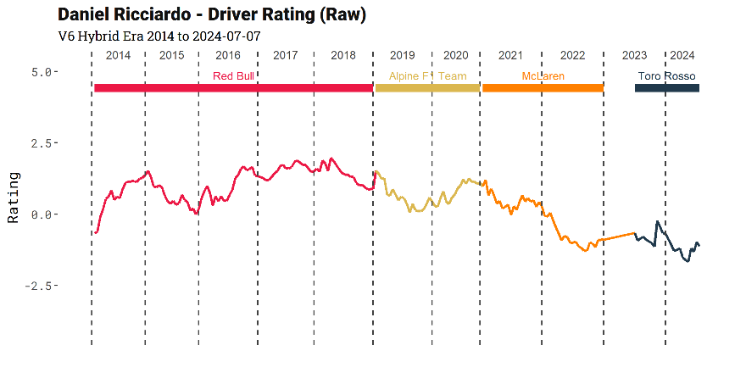
Figure 1: Daniel Riccardo raw (model-derived) coefficient
To reduce this noise and improve predictive power, we use a blended average between the model-derived coefficients and a LOESS predicted coefficient for the next race. The blended average is defined by (5), with constants determined through hyperparameter optimization against mean absolute error (MAE).
$${weight}_{raw coefficient (rc)} = min( \frac{n_{races}}{40}, \left\{\begin{aligned}0.3, &drivers \\ 0.7, &constructors\end{aligned}\right. )$$

$$β_{Blended}= {weight}_{rc} *{ β}_{raw} + (1- {weight}_{rc}) * { β}_{LOESS}$$
(5)
This smoothing methodology yields a less noisy and more accurate time series for constructor and driver ratings.
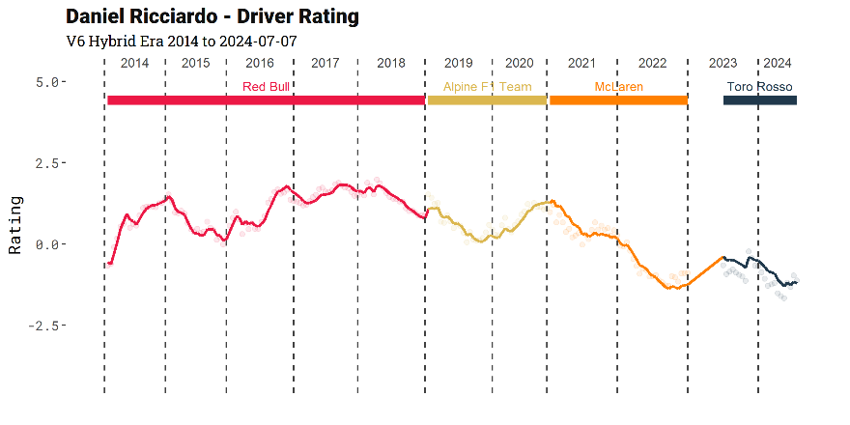
Figure 2: Daniel Riccardo LOESS-blended coefficient

Testing
To understand the influence of constructors versus drivers, we analyze the variance explained by each component. We use Kendall’s 𝜏 coefficient as our test metric due to its interpretability and robustness to outliers (versus Spearman Rho). Robustness to outliers is particularly important in DNF-inclusive models.

Test Data
For testing we look at the 2014 to 2023 Formula 1 seasons. 2012 and 2013 seasons serve as a warm start for the model while 2023 was the last completed Formula 1 season at the time of this analysis.
The test data is the immediate next race following the current race r. or instance, the model from the 2016 Spanish Grand Prix (model_{2016, Round 5} ) predicts the outcomes for the 2016 Monaco Grand Prix (2016 season, round 6). The predictions from the model are linearly ranked and used as y_{pred}. This same process is applied to get y_{pred} for each model iteration r that we have. Using an out-of-sample test set that is immediately future-facing allows us wholly predictive test method versus a backwards-facing out-of-sample test/train split.

Kendall’s Coefficient

We calculate Kendall’s coefficient at the race level and then average across all races in the test data as described in (6).
$$τ_{single race (r)}= \frac{Condordant Pairs (C) - Discordant Pairs (D)}{Combination(n_{drivers}, 2)}$$
$$τ_{Overall}= \frac{1}{R}\sum_{r = 1}^{R}{τ_{r}}$$
(6)
We extend Kendall’s coefficient to calculate partial Kendall’s Tau for constructors and drivers as described in (7).
$$τ_{Partial, Constructors}= τ_{y | Constructors ∙ Drivers }= \frac{τ_{y | Constructors} - τ_{y | Drivers }*τ_{Drivers | Constructors}}{\sqrt{(1 - τ_{y |Drivers }^{2})*(1 - τ_{Drivers |Constructors}^{2})}} \\ τ_{Partial, Drivers}= τ_{y | Drivers ∙ Constructors}= \frac{τ_{y | Drivers} - τ_{y | Constructors}*τ_{Drivers | Constructors}}{\sqrt{(1 - τ_{y |Constructors}^{2})*(1 - τ_{Drivers |Constructors}^{2})}}$$

$τ_{y | Constructors}$: the Kendall’s Tau between actual race positions (y) and constructor-only predictions
$τ_{y | Drivers}$: the Kendall’s Tau between actual race positions (y) and drivers-only predictions
$τ_{Drivers | Constructors}$: the Kendall’s Tau between constructors-only predictions and drivers-only predictions
(7)
From there, we’re able to describe the proportion variance explained by drivers versus constructors.

$$Constructor Variance Explained = \frac{τ_{Partial, Constuctors}^{2}}{τ_{Partial, Constuctors}^{2} + τ_{Partial, Drivers}^{2} }$$
(8)

Additional Models

In addition to the linear ridge regression, we design a logistic model with ridge regression. This model uses the response variable of key positional benchmarks in Formula 1 corresponding to common sportsbook markets (Hennion 2023). The three binary response variables we use are top 3 (podium), top 6, and top 10 (points finish).
The chosen test metric for the logistic ridge regression is McFadden’s R-squared due to its interpretability, ease of implementation, and robustness.

$$R_{McFadden}^{2}= 1 - \frac{log(L_{model})}{log(L_{null})}$$
$$R_{McFadden,Partial,Constructors}^{2}= \frac{log(L_{drivers}) - log(L_{model})}{log(L_{null})}$$
$$R_{McFadden,Partial,Drivers}^{2}= \frac{log(L_{constructors}) - log(L_{model})}{log(L_{null})}$$
$log\left(L_{model}\right)$ : Log-likelihood of the full model
$log\left(L_{constructors}\right)$: Log-likelihood of the constructors only model
$log\left(L_{drivers}\right)$: Log-likelihood of the drivers only model
$log\left(L_{null}\right)$: Log-likelihood of the null model
(9)
We calculate the proportion of variance explained similarly to the base model with Kendall’s coefficient as the test metric:
$$Constructor Variance Explained = \frac{R_{McFadden,Partial,Constructors}^{2}}{R_{McFadden,Partial,Constructors}^{2} + R_{McFadden,Partial,Drivers}^{2} }$$
(10)

Results

Linear Model Results

Table 1 Performance metrics for Time-Decay Ridge Regression Model
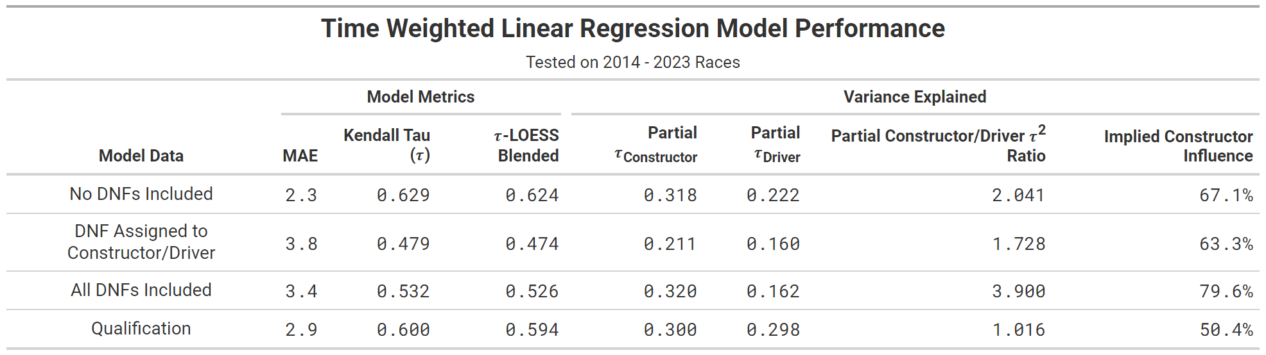
Our model testing yields the metrics displayed above. Intuitively, the DNF-Excluded model outperforms the DNF-inclusive models, as removing DNFs largely removes outlier results. Notably, the LOESS-blended coefficients perform better than the raw coefficients.
The 67.1% variance explained by constructors in the DNF-excluded model contrasts with the 88% constructor-explained variance that Keresten (2023) reported. The initial intuitive thought is that the large difference is explained by the two additional years the model described covers. Furthermore, the 2014-2021 timeframe perfectly encapsulates the 8 consecutive championships Mercedes won; 5 of which had Mercedes drivers finishing 1st and 2nd. However, when testing the ridge regression model on the same 2014-2021 cohort, we found an implied constructor influence of 70.1%. Consequently, we find only a small portion of the difference is explained through a difference in model data. The other differences are explained through the difference in the model itself and the model testing.
In the DNF-inclusive model, 79.6% of the variance is explained by constructors, compared to 86% in Bell's DNF-inclusive model (Bell 2016). That difference can be likely explained through the wider time frame Bell uses (1979 - 2014). Classification percentage, a percentage of how many racers finished 90%+ of the race, has significantly increased over time. Consequently, constructor influence when looking at races before the V8 (2006 - 2013) era may be more of a measure of reliability than ability. We also observe a slight drop in classification percentage at the start of new engine regulations, suggesting our model may lose predictive power with the new regulations set for the 2026 season.
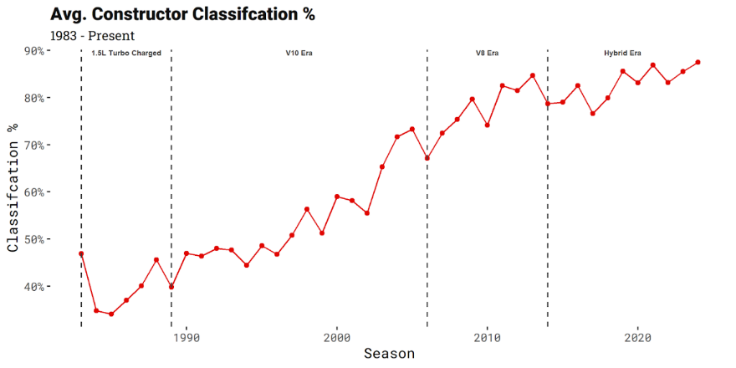
Additionally, he decreased relative importance of constructors (50.4%) in predicting qualifying is noteworthy. The increased driver importance during qualification makes intuitive sense, as factors like race strategy and pit stops are essentially non-existent in qualifying compared to races.

Logistic Model Results
Table 2 Performance metrics for Time-Decay Ridge Logistic Regression Model
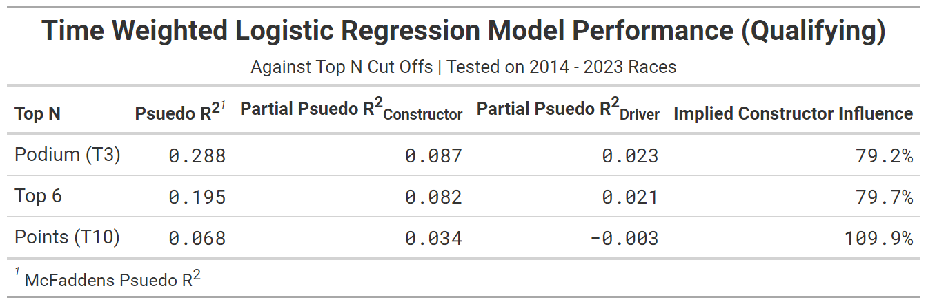
Our logistic model against the 3 key sportsbook benchmarks (Top 3/6/10) suggests a larger constructor influence when examining broader cohorts compared to the rank-ordered predictions of the primary ridge regression model. The increased constructor importance suggests that constructors are the primary driver into placing drivers into a given cohort (e.g. points, top 6), but the intra-cohort ordering is a larger function of driver ability.

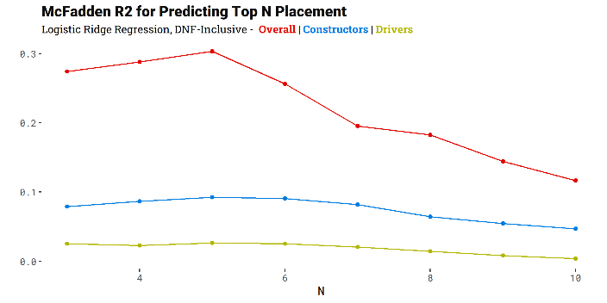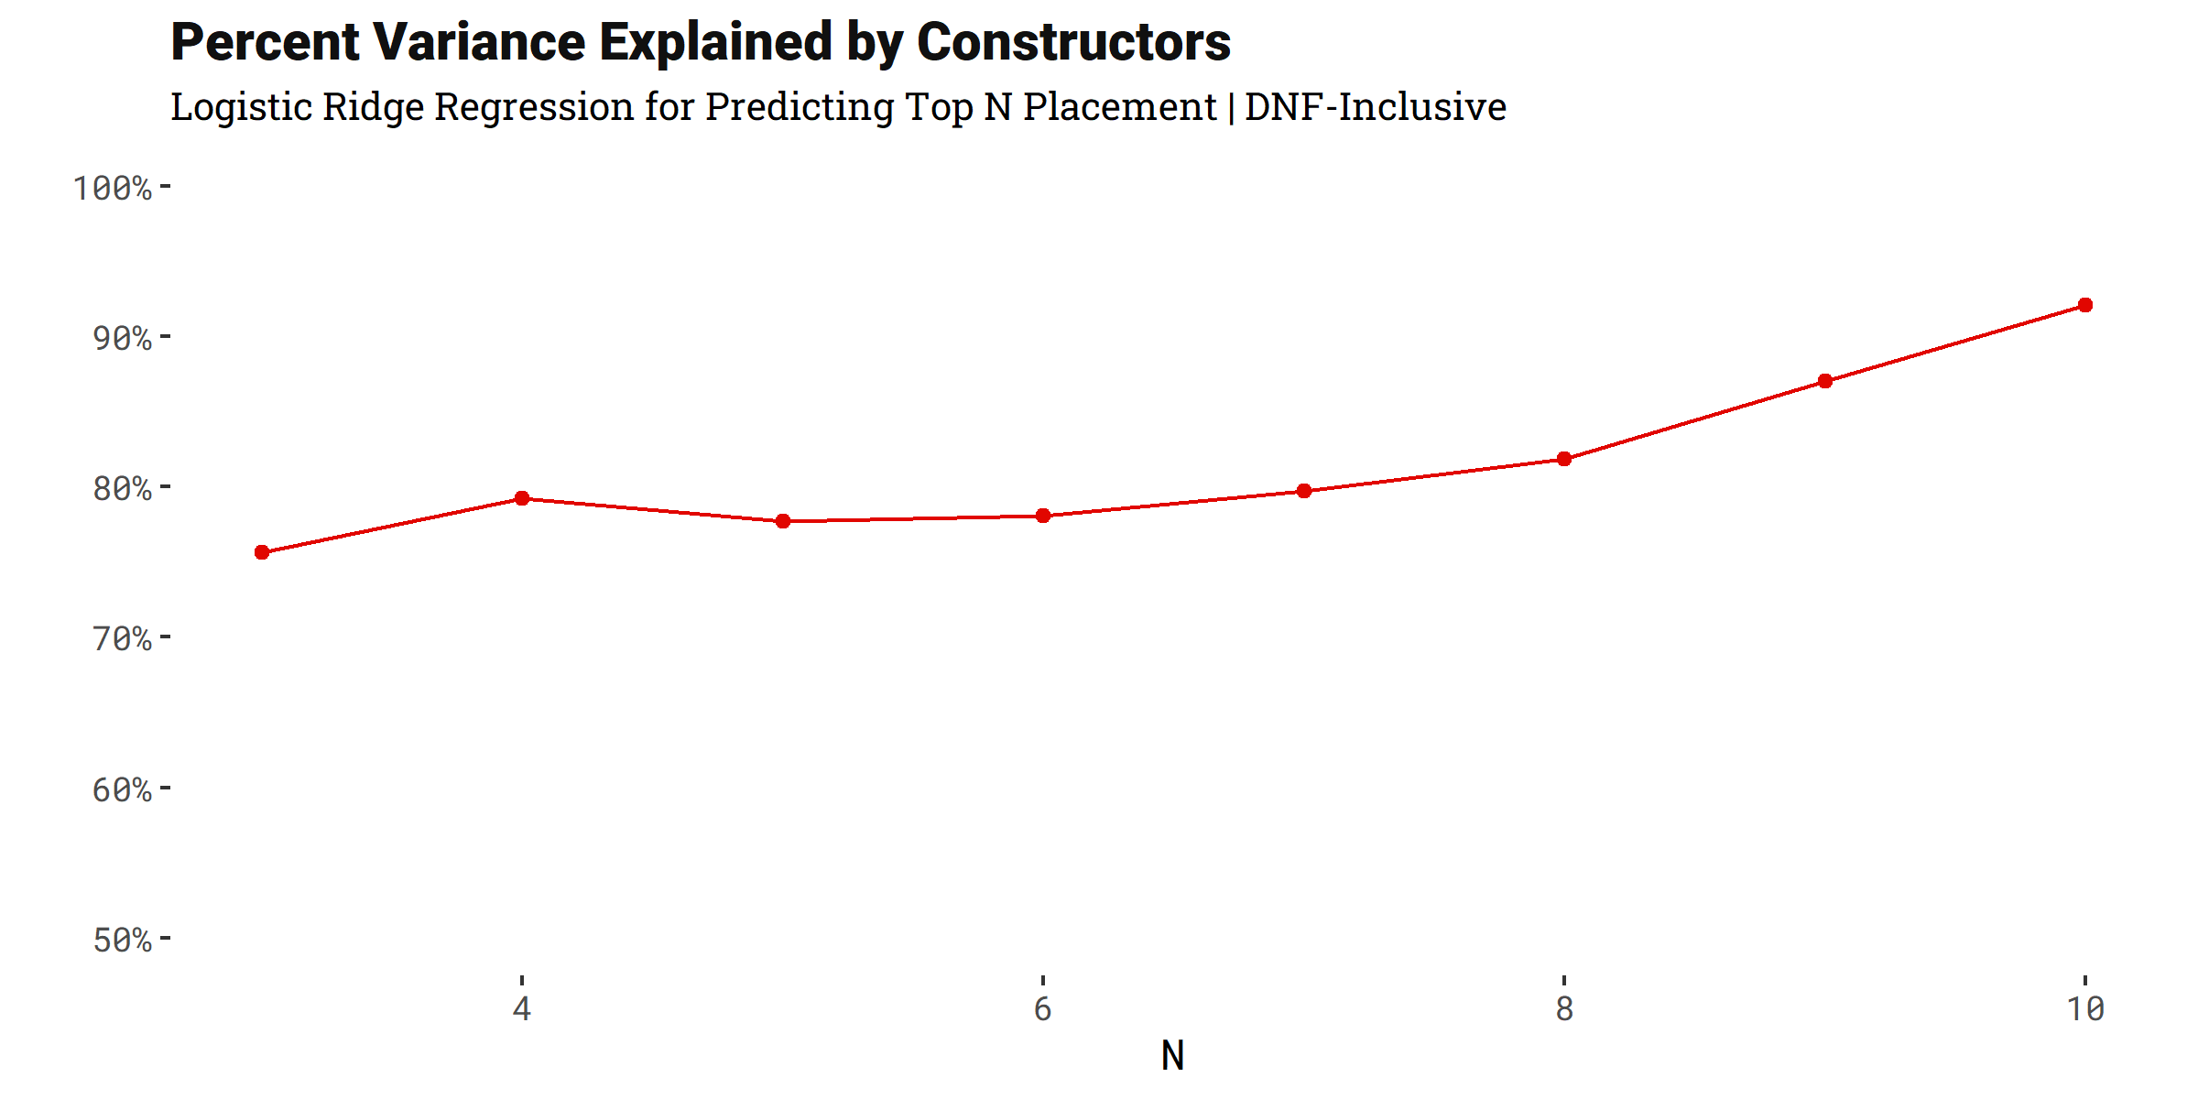
Figure 3 Model Metrics and Variance Explained for Top N Logistic Models
We extend the logistic model for all Top N finishes for N 3 to 18. We find McFadden’s R² dips below 0.0 for all N greater than 10. We see better model performance for lower values of N. Most interestingly, we see the importance of constructors in explaining variance steadily rise for increasing N, which supports the broader conclusion that constructors are increasingly important for placing within cohorts. Though, its worth noting that model robustness declines for higher values of N. Additionally, we see a local maximum in model performance for N = 5 before model performance drops off at a higher rate. Notably we do not see significant decline, if it all, in partial R² for both constructors and drivers for N < 7.

Driver and Constructor Coefficients
Analyzing driver and constructor coefficients provides additional context for intra-team driver performances and inter-team driver comparisons.
As shown below, we can better track Max Verstappen’s model coefficient compared to his longtime teammate Daniel Ricciardo. Despite Ricciardo finishing with 92 points compared to Verstappen’s 49 points in the 2015 season, their model coefficients were similar. The model attributed the point difference to constructor quality rather than driver quality. This trend continued over the next three seasons when the pair shared a team at Red Bull.

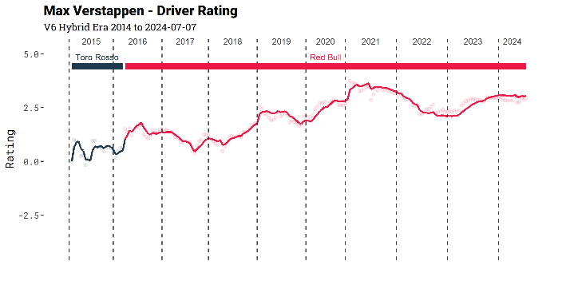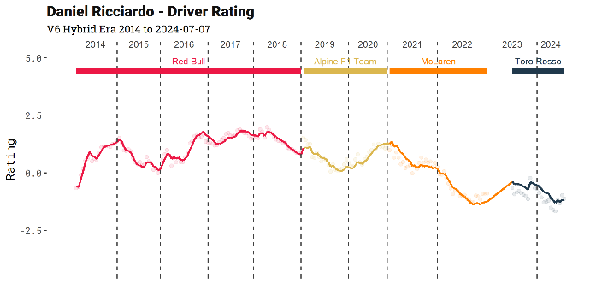
Figure 4: Max Verstappen vs Daniel Ricciardo LOESS-Blended Coefficients/Ratings
A similar phenomenon is observed in comparing constructor coefficients. Mercedes is consistently seen as the dominant constructor throughout the 2014-2021 period, coinciding with their eight consecutive World Constructors' Championships.
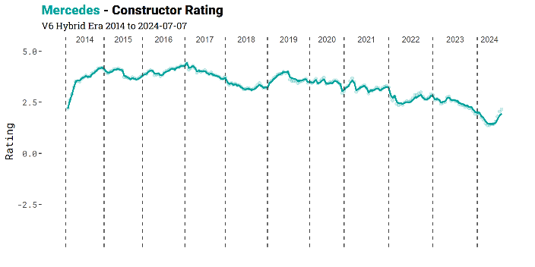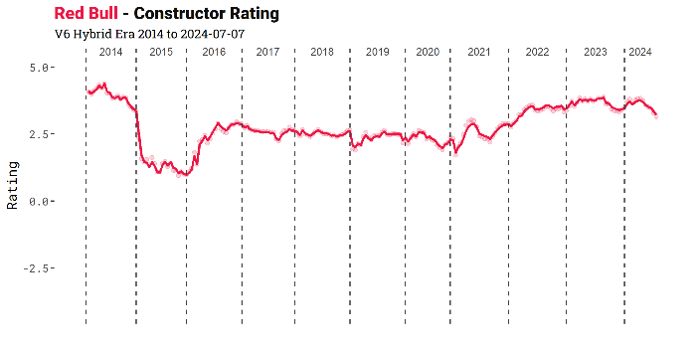
Figure 5: Mercedes vs Red Bull LOESS-Blended Coefficients/Ratings
While coefficients are useful for intra-team driver and constructor comparisons, similar conclusions can often be drawn from Formula 1 point totals. The back-and-forth between Verstappen and Ricciardo is evident in their point totals for the 2016-2018 seasons. Mercedes' dominance over Red Bull is also clear from their point totals relative to other constructors.
The unique insight provided by the ridge regression model lies in inter-team driver comparisons. This is illustrated with Max Verstappen, Lewis Hamilton, and Valtteri Bottas. Hamilton and Bottas finished 1st and 2nd respectively in both the 2019 and 2020 seasons, with Verstappen finishing 3rd in both seasons. Despite these results, Verstappen’s driver coefficient for both seasons is higher than Bottas’s and in line with Hamilton's.
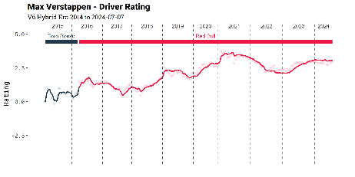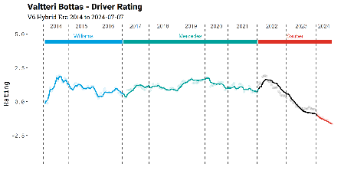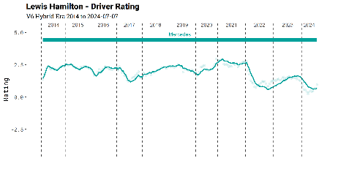
Figure 6 Max Verstappen, Valtreri Bottas, Lewis Hamilton LOESS-Blended Coefficients/Ratings
Bottas outperforming Verstappen in the World Driver’s Championship is largely attributed to the quality of the Mercedes in the 2019 and 2020 seasons. Verstappen’s talent was fully displayed in the 2021 season when he won the World Drivers' Championship as the gap between Mercedes and Red Bull closed. Hamilton and Bottas finished 2nd and 3rd respectively.

Discussion

Model Discussion
The overall DNF-Excluded model has a strong predictive power with a Kendall’s coefficient of 0.624. This robustness instills confidence in the other derived conclusions. Measuring the coefficients of both drivers and constructors over time enables more informative inter-constructor driver comparisons
The 67.1% variance explained by constructors, alongside model metrics for qualification and logistic regression models, highlights the significant impact of constructors on driver finishing positions. The logistic model, in particular, highlights the crucial role of constructors in determining cohort placements. Conversely, the qualification models emphasize the relative importance of drivers, suggesting potential value in incorporating qualification-informed models.

Model Extensibility
There are many opportunities to expand the modeling process outlined throughout this paper. For the sake of interpretability, the current model only includes drivers and (parent) constructors as features. Incorporating additional features such as circuit type and separating the engine and constructor components could enhance predictive accuracy. Moreover, the existing prediction process yields singular predictions. Implementing a bootstrapped model could provide probabilistic outcomes, thereby increasing the model's applicability to sports betting.
The presented methodology can also be extended to previous eras of Formula 1, allowing for cross-era comparisons. Expanding the model to cover earlier periods would likely necessitate recalibrating the time-decay factor to account for significant changes when engine regulations are altered. Given the impending new engine regulations in the 2026 Formula 1 season, it will be essential to recalibrate the model to maintain its relevance and accuracy.
The methodology can be extended to other sports, particularly racing related ones. The methodology can largely be shifted over to horse racing, sailboat racing, and other motorsports. Extending the methodology to one-make (spec) racing where cars usually have the same chassis, powertrain, tires, brakes, and fuel would be an interesting contrast to the analysis presented in this paper. For example, we would expect almost all the variance to be explained by drivers in Formula 2 where all the chassis and engines are the same. Contrasting to semi-spec series such as IndyCar and Formula-E where chassis are the same, but power units can vary could provide a unique perspective on the impact of the driver.

Applications & Conclusions

Table 3: Top 10 Constructor/Driver composite rankings as of the end of the 2023 F1 Season
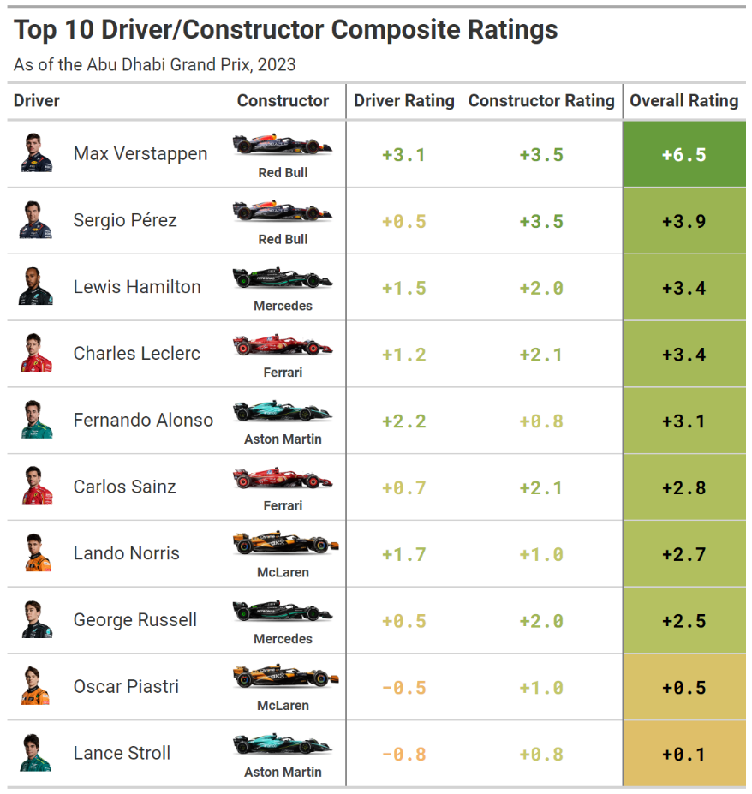
As mentioned in the Results section, the main applicability of the model is to discern driver impact amongst drivers on different teams. Additionally we are able to capture point-time ratings for constructor/driver combinations to predict race outcomes as highlighted in the table above.
In conclusion, this study provides a nuanced understanding of the respective impacts of drivers and constructors on Formula 1 race outcomes. By leveraging a robust ridge regression model with LOESS smoothing and assessing predictive performance through Kendall’s coefficient, we offer valuable insights into inter-constructor driver comparisons and the overall influence of constructors. The findings underscore the substantial role of constructors in determining race results, particularly in the context of modern Formula 1. The proposed methodology and findings pave the way for future research that can refine and extend these models, incorporating additional features and expanding to different eras in the sport. Such advancements hold promise for enhancing both predictive accuracy and practical applications, such as sports betting and strategic decision-making within Formula 1 teams.

Acknowledgements
I would like to express my sincere gratitude to Akhil Raju and Naveen Venkatesan for their invaluable assistance as reviewers of this paper. Their insightful comments and constructive feedback greatly contributed to the improvement and clarity of the final manuscript.

References
Bell, A., Smith, J., Sabel, C. and Jones, K. (2016) Formula for success: Multilevel modelling of Formula One Driver and Constructor performance, 1950–2014. Journal of Quantitative Analysis in Sports, Vol. 12 (Issue 2), pp. 99-112. https://doi.org/10.1515/jqas-2015-0050
Budzinski, O. and Feddersen, A. (2020) Measuring competitive balance in Formula One racing. In Outcome uncertainty in sporting events (pp. 5-26). Edward Elgar Publishing.
Eichenberger, R. and Stadelmann, D. (2009) Who is the best Formula 1 driver? An economic approach to evaluating talent. Economic Analysis and Policy, 39(3), p.389.
Ergast. (n.d.). Ergast Developer API. Available at: https://ergast.com/mrd/methods/sprint/ (Accessed: 17 July 2024).
f1dataR. (n.d.). The f1dataR package. Available at: https://cran.r-project.org/web/packages/f1dataR/index.html (Accessed: 17 July 2024).
Formula 1. (n.d.). Formula 1. Available at: https://www.formula1.com/en.html (Accessed: 17 July 2024).
Fry, J., Brighton, T. and Fanzon, S. (2024) Faster identification of faster Formula 1 drivers via time-rank duality. Economics Letters, 237, p.111671.
Hennion, N. and Maher, T. (2023). How to Bet on Formula 1. Forbes. Available at: https://www.forbes.com/betting/formula-1/how-to-bet-on-formula-1/ (Accessed: 17 July 2024).
Jacobs, J. (2017). Deep Dive on Regularized Adjusted Plus-Minus I: Introductory Example. Squared2020. Available at: https://squared2020.com/2017/09/18/deep-dive-on-regularized-adjusted-plus-minus-i-introductory-example/ (Accessed: 17 July 2024).
Medvedovsky, K. and Patton, A. (2022) Daily adjusted and regressed Kalman optimized projections| DARKO. Accessed on, 17.
Moore, J., Dottle, R. and Paine, N. (2018). Formula One Racing. FiveThirtyEight. Available at: https://fivethirtyeight.com/features/formula-one-racing/ (Accessed: 17 July 2024).
Phillips, A. (2014) Uncovering Formula One driver performances from 1950 to 2013 by adjusting for team and competition effects. Journal of Quantitative Analysis in Sports, Vol. 10 (Issue 2), pp. 261-278. https://doi.org/10.1515/jqas-2013-0031
Rockerbie, D. W. and Easton, S. T. (2022) ‘Race to the podium: separating and conjoining the car and driver in F1 racing’, Applied Economics, 54(54), pp. 6272–6285. doi: 10.1080/00036846.2022.2083068.
Spurgeon, B. (2009) Age Old Question of Whether it is the Car or the Driver that Counts. Formula 1, 101.

van Kesteren, E. and Bergkamp, T. (2023) Bayesian analysis of Formula One race results: disentangling driver skill and constructor advantage. Journal of Quantitative Analysis in Sports, Vol. 19 (Issue 4), pp. 273-293. https://doi.org/10.1515/jqas-2022-0021

Appendix

A1. Metrics by Driver-Season Type
Table 4: Mean Absolute Error (MAE) by Driver Type
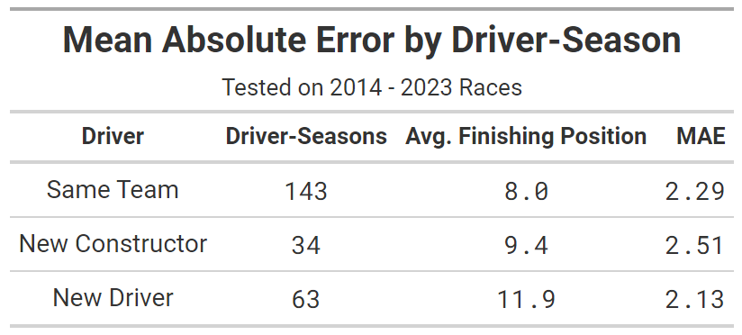
When stratifying driver-seasons by whether the are a new driver, joining a new team, or staying with the same team. As expected, the model is stronger at predicting the performance of teams staying with the same constructor than those that have switched teams. Counter-intuitively to that, we see that the error amongst new drivers altogether is better than the other categories. The lower error amongst that cohort can potentially by explained by the nature of the constructors new drivers go to. New drivers are often going to back-markers or mid-field teams that feed the contenders (e.g. Toro Rosso Red Bull, Haas Ferrari, Williams Ferrari).

A2. Parent Constructor Mapping
Table 5: Parent Constructor Mapping
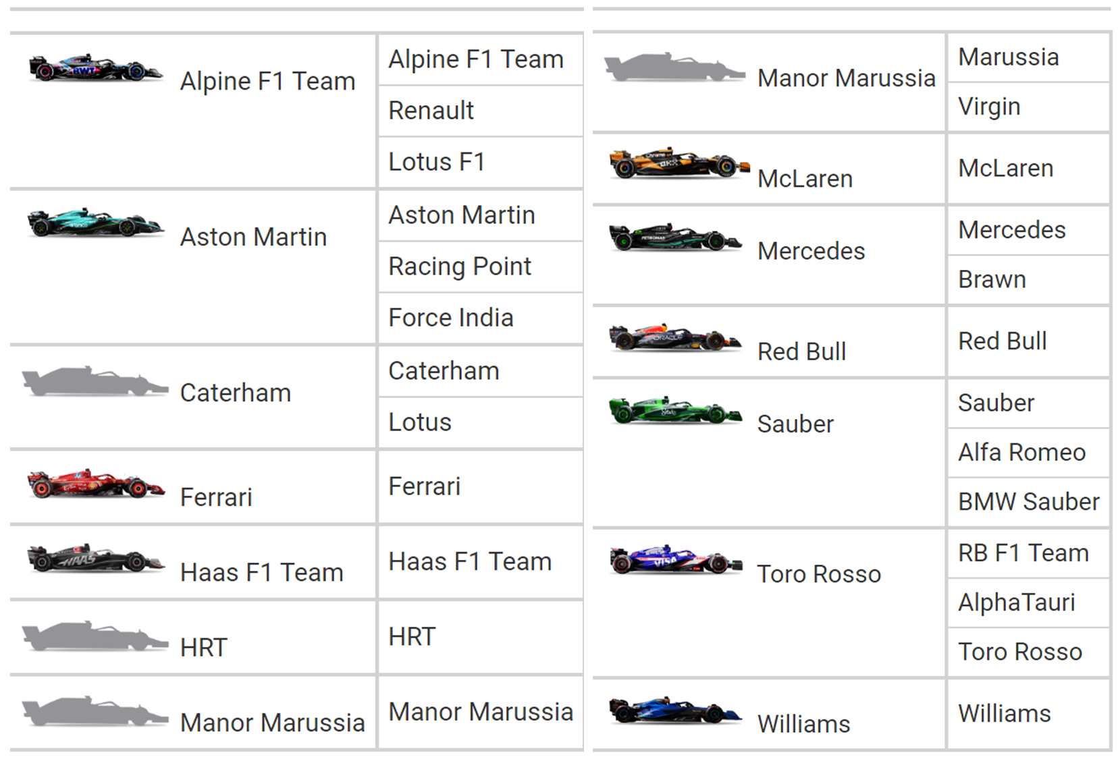

A3. Driver/Constructor Ratings as of 2024 British GP

Table 6: Driver/Constructor Composite Rankings as of the 2024 British GP
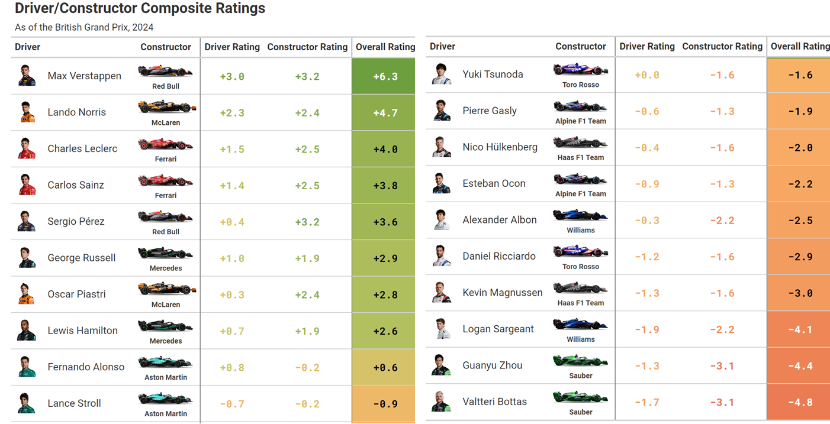

Table 7: Driver Rankings as of the 2024 British GP
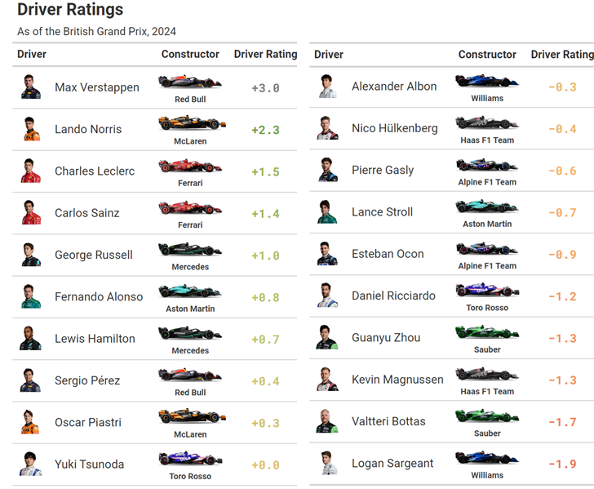

Table 8: Constructor Rankings as of the 2024 British GP
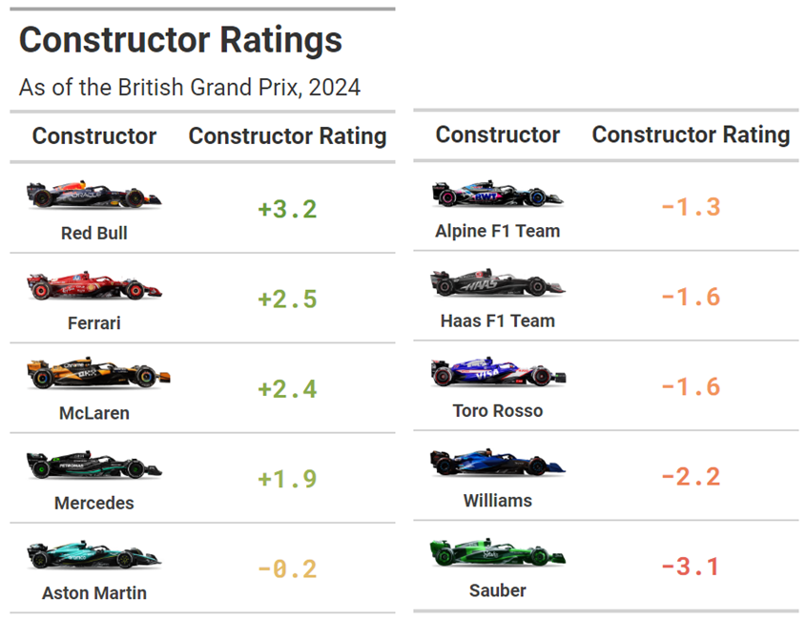

A4. Driver/Constructor Coefficient/Ratings Trends 2014 - 2024 British GP

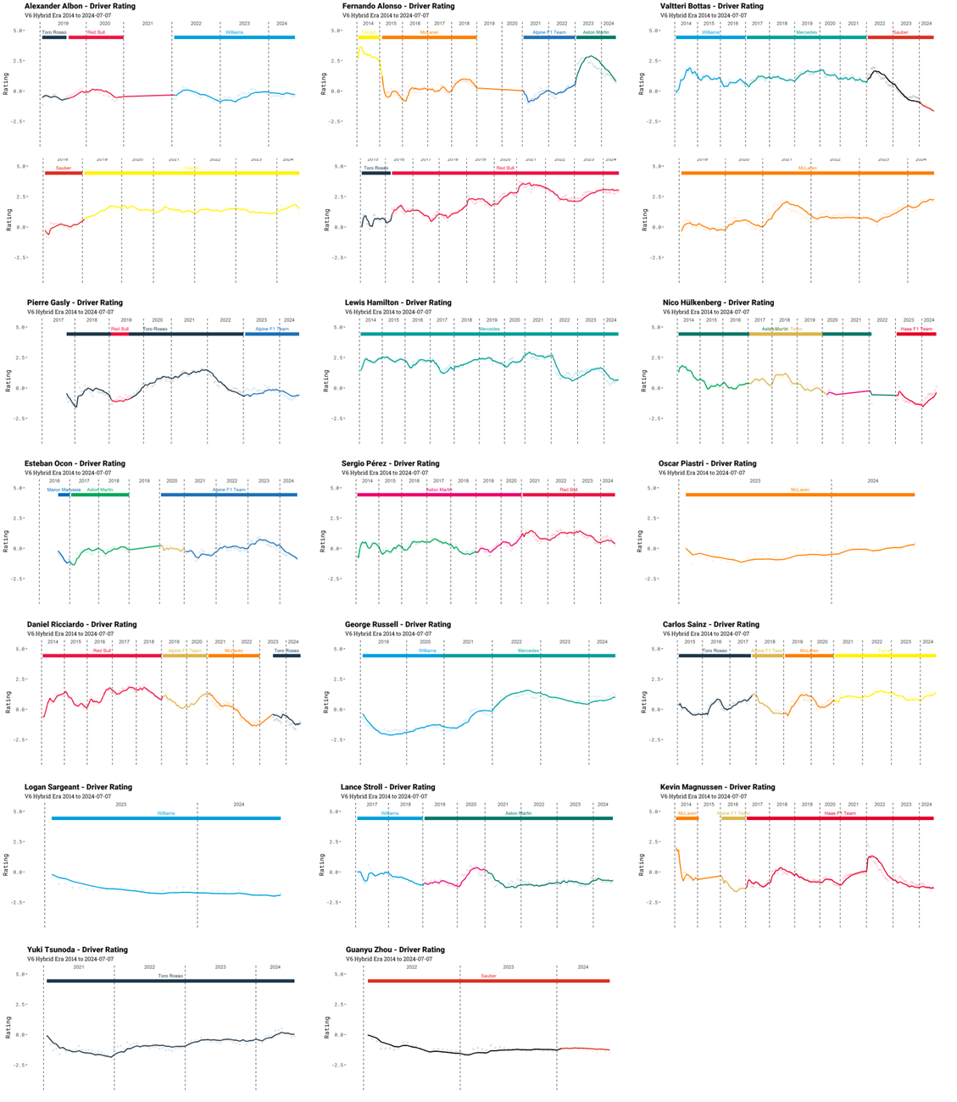
Figure 7: Driver Ranking/Coefficient Trend 2014 - 2024 British GP
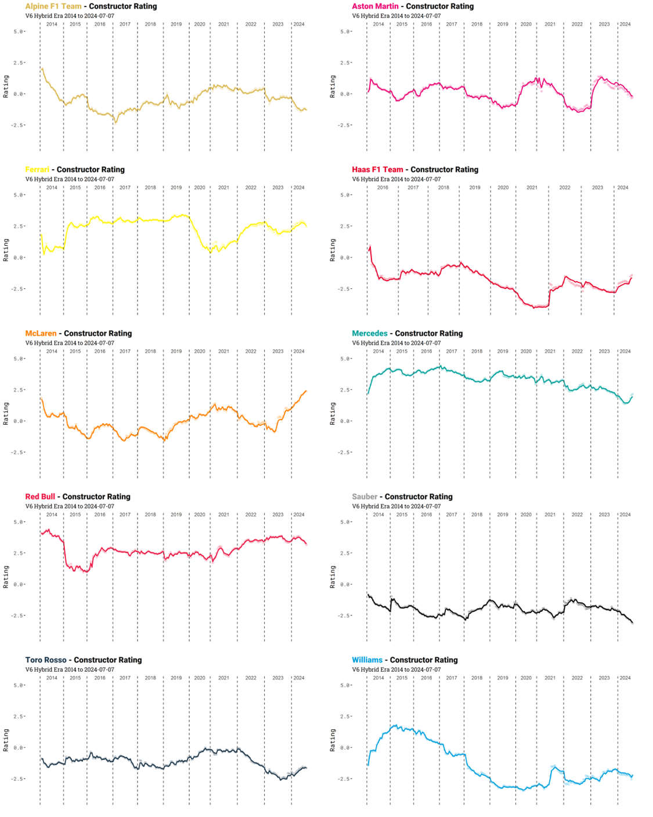
Figure 8: Constructor Ranking/Coefficient Trend 2014 - 2024 British GP

